CMR TECHNICAL CAMPUS

UGC AUTONOMOUS
Accredited by NBA & NAAC with ‘A’ Grade
Approved by AICTE, New Delhi and JNTU Hyderabad
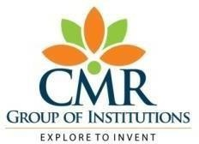
Department of Computer Science and Engineering
Advances in Artificial Intelligence and Blockchain Technologies for Early Detection of Human Diseases


Early detection of human diseases plays a crucial role in improving treatment outcomes and reducing health risks. With the rapid growth of healthcare data and machine learning techniques, intelligent systems can assist in predicting diseases at an early stage. This project proposes a web-based system for the early detection of human diseases using machine learning algorithms. The system allows users to enter their health-related details and symptoms through an interactive interface. The entered data is then analyzed by a trained prediction model to determine the likelihood of a disease. The platform ensures secure handling of user information while providing quick and reliable prediction results. This approach helps users become aware of possible health conditions at an early stage and encourages timely medical consultation. The system also assists healthcare stakeholders by providing a faster and more efficient screening mechanism. Overall, the proposed solution improves accessibility, reduces diagnosis time, and supports proactive healthcare management through technology.

  The project titled “Early Detection of Human Diseases using Machine Learning” focuses on developing a smart system that helps in identifying potential diseases at an early stage using medical datasets and predictive models. The system allows users to enter their health details, while service providers can manage datasets, train machine learning models, and analyze prediction results through a web-based platform.  Machine learning is a technology that enables computers to learn patterns from data and make predictions without being explicitly programmed. Unlike traditional methods that rely on manual analysis, machine learning models can analyze large amounts of health data to detect possible diseases quickly and accurately, thereby supporting faster medical decisions and improving early diagnosis. | 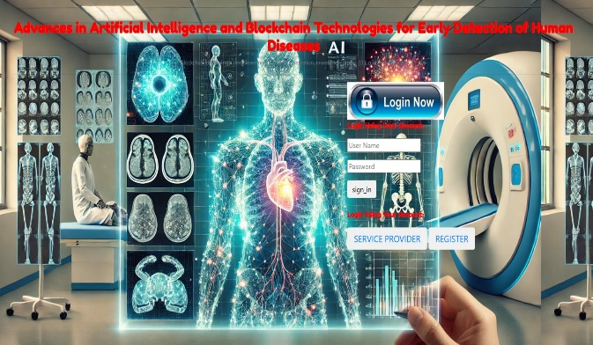
 | Batch-19:  G.SIRISHA 247R1A0582  D.SHRUTHIK 247R1A0578  S.YASHWANTH 247R1A05E5  FACULTY SUPERVISOR  Dr.V.Naresh Kumar
- Traditional Hospital Diagnosis Systems.
- Online Symptom Checker Platforms.
- Electronic Health Record (EHR) Based Analysis Systems.
- Medical Expert Rule-Based Diagnosis Systems.
- AI-Based Health Monitoring and Prediction Platforms.

- Electronic Health Record (EHR) Based Analysis Systems.
- Medical Expert Rule-Based Diagnosis Systems.
- AI-Based Health Monitoring and Prediction Platforms.

- Medical Expert Rule-Based Diagnosis Systems.
- AI-Based Health Monitoring and Prediction Platforms.

- AI-Based Health Monitoring and Prediction Platforms.
The proposed system for early detection of human diseases provides an efficient and data-driven platform to help identify potential diseases at an early stage. The system uses machine learning techniques to analyze medical datasets and patient symptoms, enabling faster and more accurate predictions. By integrating web technologies with predictive models, the system simplifies the process of disease detection and reduces manual effort in analyzing health data. This project highlights the benefits of intelligent systems in supporting early diagnosis and improving healthcare decision-making.

